1. Go online and find out what Ruby's gets.chomp does.

Gets is a method that accepts a single line of data from the standard input and returns a string. In our case, the standard input is the keyboard. We can use gets to accept user input. The gets method attaches a n to the end of the input and returns a string. (A new line character). We can see this from the Ruby code below. [chomp](http://ruby-doc.org/core-2.2.0/String.html#method-i-chomp) is a method for Strings. The chomp method returns a new string, with the given record separator removed from the end of the string. If the given record separator is not present, the method removes carriage return characters

1. Can you find other ways to use it? Try some of the samples you find.

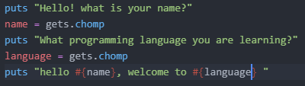

Output:

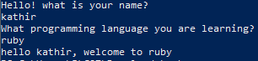

1. Write another "form" like this to ask some other questions.

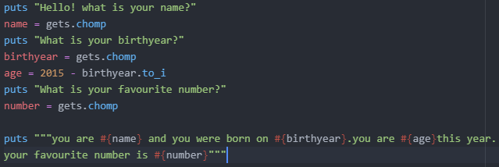

Output:

